**Experiment # 10**

**OBJECTIVE**

**To become familiar with Structures in C++**

**Structures:**

A structure is a collection of simple variables. The variables in a structure can be different types. Some can be int, some can be float, & so on. The data items in a structure are called the members of the structure. There are 3 main aspects of a structure namely; Declaration, Definition & Accessing a structure.

**Declaring & Defining a Structure & accessing its Members**The structure declaration tells how the structure is organized. It specifies what members the structure will have. Any structure is declared before the main function.

**Syntax:**

struct vari

{int choice;

float fst;

float snd;};

Definition of this structure is carried out in the start or before accessing the members in the main() function as follows:

main()

{vari vari1;

Here a variable called vari1 is defined of the type structure vari. This definition reserves enough space in the memory to hold all the members of vari1.

Declaration & definition of a structure can be combined into a single statement as follows:

struct

{int choice;

float fst;

float snd;}vari1;

Here no separate statement is required for the structure definition; instead the variable vari1 is placed at the end of the declaration which defines the structure. This method of definition is not as flexible or clear as declaring & defining separately.

Accessing the members of a structure defined in both ways as above is the same.

**Example:01**

***// Program for declaration & definition separately***

#include <iostream.h>

#include <conio.h>

struct vari

{int choice;float fst;int snd;};

void main()

{

vari vari1;

cout<<"Enter a number to show the table: ";

cin>>vari1.fst; ***// Accessing the member of the structure***

for (vari1.snd=1;vari1.snd<=10;vari1.snd++)

cout<<vari1.fst<<" x "<<vari1.snd<<" = "<<vari1.fst*vari1.snd<<endl;

getche();

}

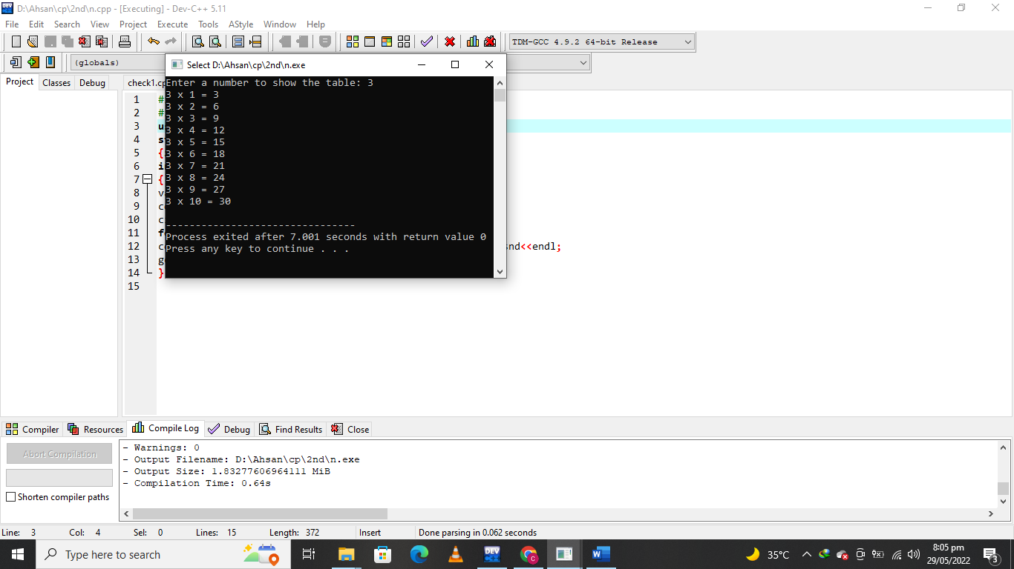

***Example #02***

***// Program for combined declaration & definition***

#include <iostream.h>

#include <conio.h>

struct

{int fact;int fst;int snd;}vari;

void main()

{

vari.fact=1;

cout<<"\nEnter a number to find its factorial: ";cin>>vari.fst;

for (vari.snd=1;vari.snd<=vari.fst;vari.snd++)

{

vari.fact=vari.fact*vari.snd;};cout<<"\nThe factorial of "<<vari.fst<<" is "<<vari.fact<<endl;

}

getche();

}

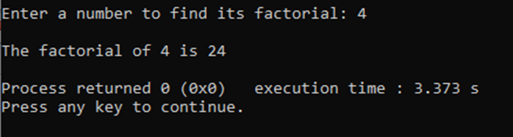

**Lab Task:**

QNo:01 Compile and Execute the given programs and display outputs.

QNo:02 Develop a Code in C++ that declares a structure to store country name and population in millions .it defines two structure variables and inputs values .and then display the country name with more population.

**QUESTION NUMBER : 01:**

Compile and Execute the given programs and display outputs.

**PROGRAM:**

#include <iostream>

#include <conio.h>

using namespace std;

struct

{int fact;int fst;int snd;}vari;

int main()

{

vari.fact=1;

cout<<"\nEnter a number to find its factorial: ";cin>>vari.fst;

for (vari.snd=1;vari.snd<=vari.fst;vari.snd++)

{

vari.fact=vari.fact*vari.snd;};cout<<"\nThe factorial of "<<vari.fst<<" is "<<vari.fact<<endl;

}

}

**OUTPUT:**



**QUESTION NUMBER : 02:**

Develop a Code in C++ that declares a structure to store country name and population in millions .it defines two structure variables and inputs values .and then display the country name with more population.

**PROGRAM:**

#include <iostream>

using namespace std;

struct Country

{

int cid;

string name;

};

struct Cities

{

string city_name;

int male_population;

int female_population;

struct Country *country;

};

void DisplayMax(Cities cities[4])

{

Cities max_city = cities[0];

int max_pop = cities[0].male_population + cities[0].female_population;

for(int i = 1; i < 4; i++)

{

if(max_pop < cities[i].male_population + cities[i].female_population)

{

max_pop = cities[i].male_population + cities[i].female_population;

max_city = cities[i];

}

}

cout<<"The city with the highest male and female population is:\n";

cout<<"Name: "<<max_city.city_name<<endl;

cout<<"Male population: "<<max_city.male_population<<endl;

cout<<"Female population: "<<max_city.female_population<<endl;

cout<<"Country name: "<<(*max_city.country).name<<endl;

cout<<"cid: "<<(*max_city.country).cid<<endl;

}

int main()

{

Country Kenya = {254, "Kenya"};

Country USA = {001, "USA"};

Country UK = {44, "United Kingdom"};

Country France = {33, "France"};

Cities Nairobi = {"Nairobi", 2192452, 2204376, &Kenya};

Cities Washington = {"Washington DC", 334355, 371394, &USA};

Cities London = {"London", 4486000, 4496000, &UK};

Cities Paris = {"Paris", 1101500, 1146000, &France};

Cities cities[] = {Nairobi, Washington, London, Paris};

DisplayMax(cities);

return 0;

}

**OUTPUT:**

